**📱 Flipkart Mobiles Sales Data Warehouse Project – Using Snowflake**

**Project Objective**

To design a cloud-based data warehouse in **Snowflake** that processes, stores, and analyses Flipkart mobile phone sales data to provide insights like top-selling models, price trends, customer behavior, and regional performance.

**Use Case Scenario**

Imagine you're part of the Flipkart Analytics team. You’re building a data warehouse that:

* Tracks sales of **mobile phones** across India
* Monitors trends in pricing, customer ratings, returns
* Analyses sales by **brand**, **model**, **region**, and **time**
* Supports marketing, supply chain, and product teams

**Project Components Overview**

|  |  |  |
| --- | --- | --- |
| **Layer** | **Tools/Services** | **Purpose** |
| Data Source | Sample Flipkart sales dataset (CSV/JSON/Parquet) | Simulate raw e-commerce data |
| Ingestion | Python, SnowSQL, Fivetran, ADF (optional) | Load raw data into Snowflake |
| Storage | Snowflake (Raw, Stage, and Core layers) | Centralized cloud storage |
| Transformation | Snowflake SQL / dbt / Snowpark (optional) | Clean, join, and aggregate data |
| Analytics | Power BI / Tableau / Streamlit Dashboard | Build sales reports & KPIs |
| CI/CD (optional) | GitHub + dbt + GitHub Actions | Version-controlled data modelling |

**Flipkart Mobiles Dataset – Schema**

|  |  |  |
| --- | --- | --- |
| **Column Name** | **Description** | **Data Type** |
| Brand | Brand name of the mobile (e.g., Samsung) | STRING |
| Model | Model name (e.g., Galaxy M14) | STRING |
| Color | Color variant (e.g., Blue, Black) | STRING |
| Memory | RAM (e.g., 4GB, 6GB) | STRING |
| Storage | Internal storage (e.g., 64GB, 128GB) | STRING |
| Rating | Customer rating (1.0–5.0) | FLOAT |
| Selling Price | Current selling price on Flipkart | NUMBER |
| Original Price | Original price before discount | NUMBER |

**Project Screenshots**

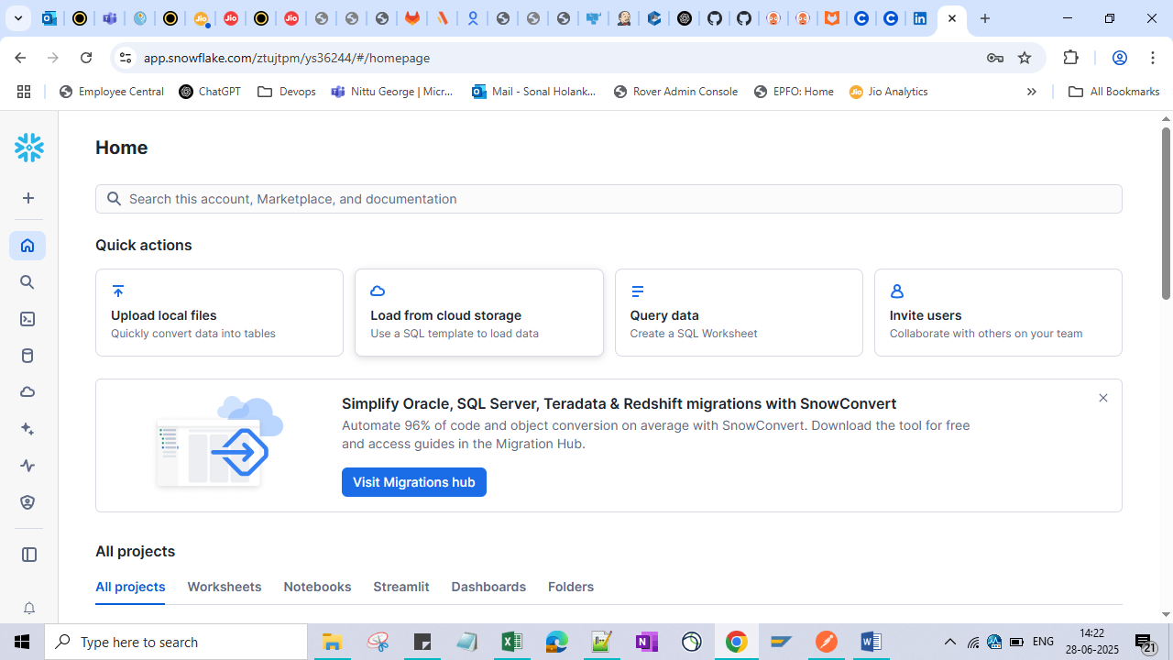

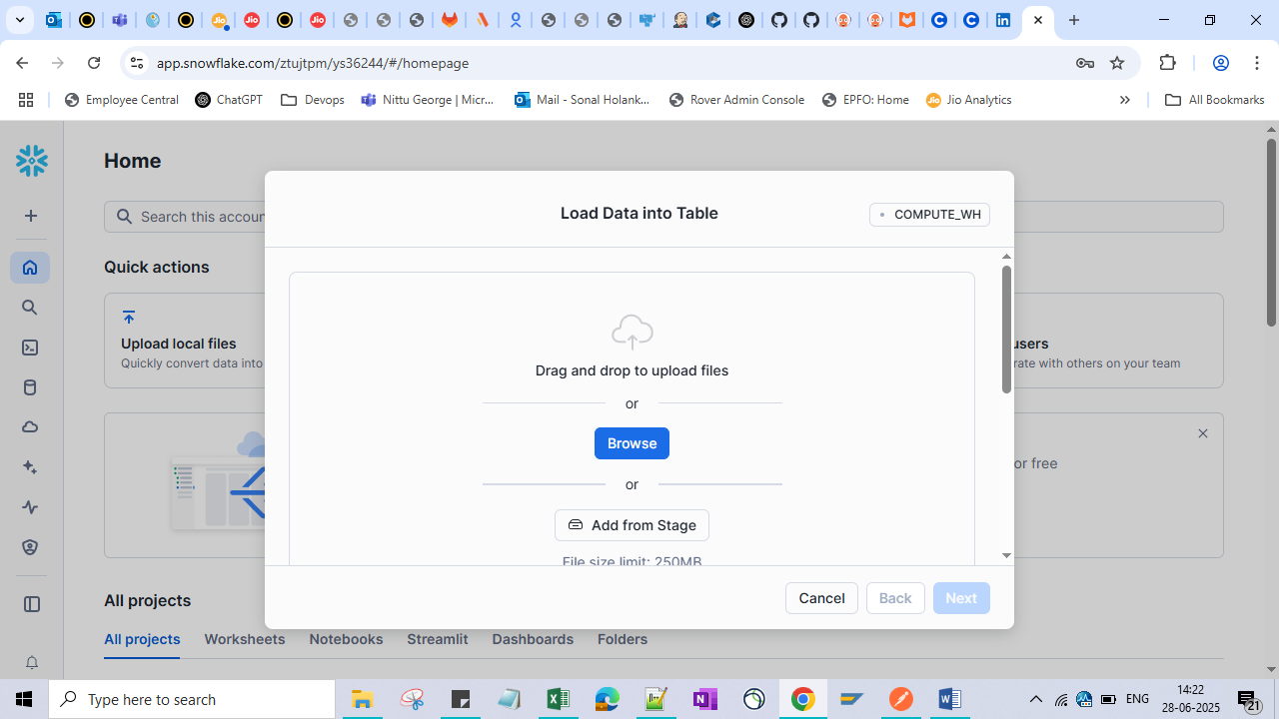

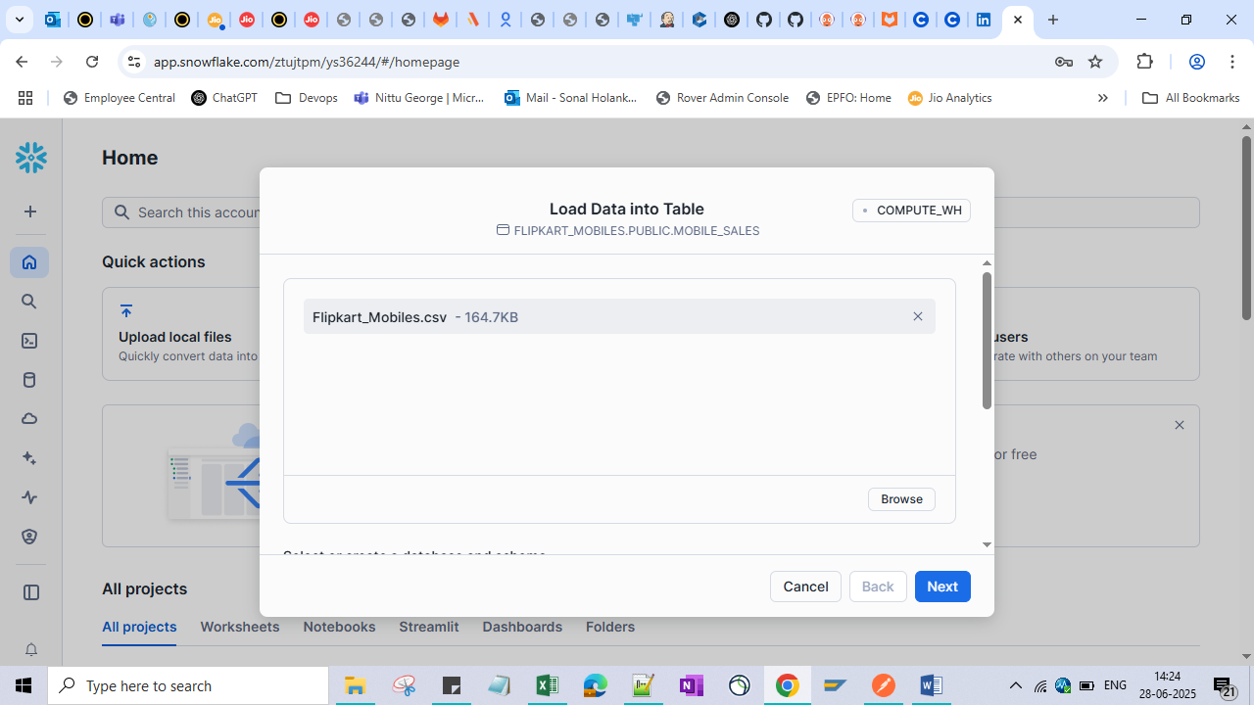

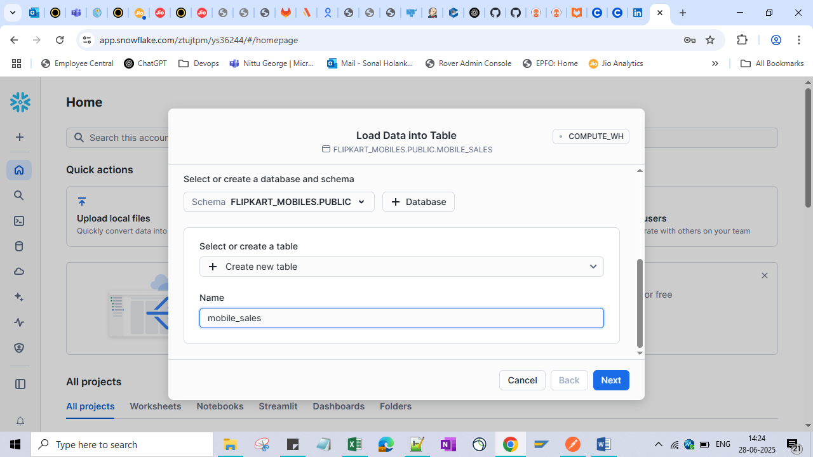

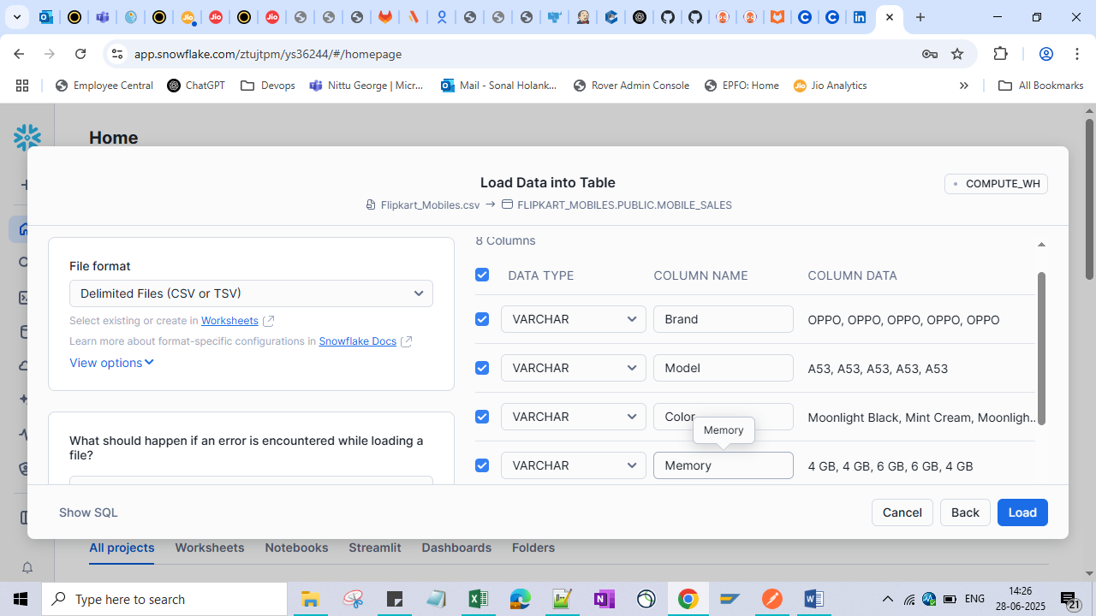

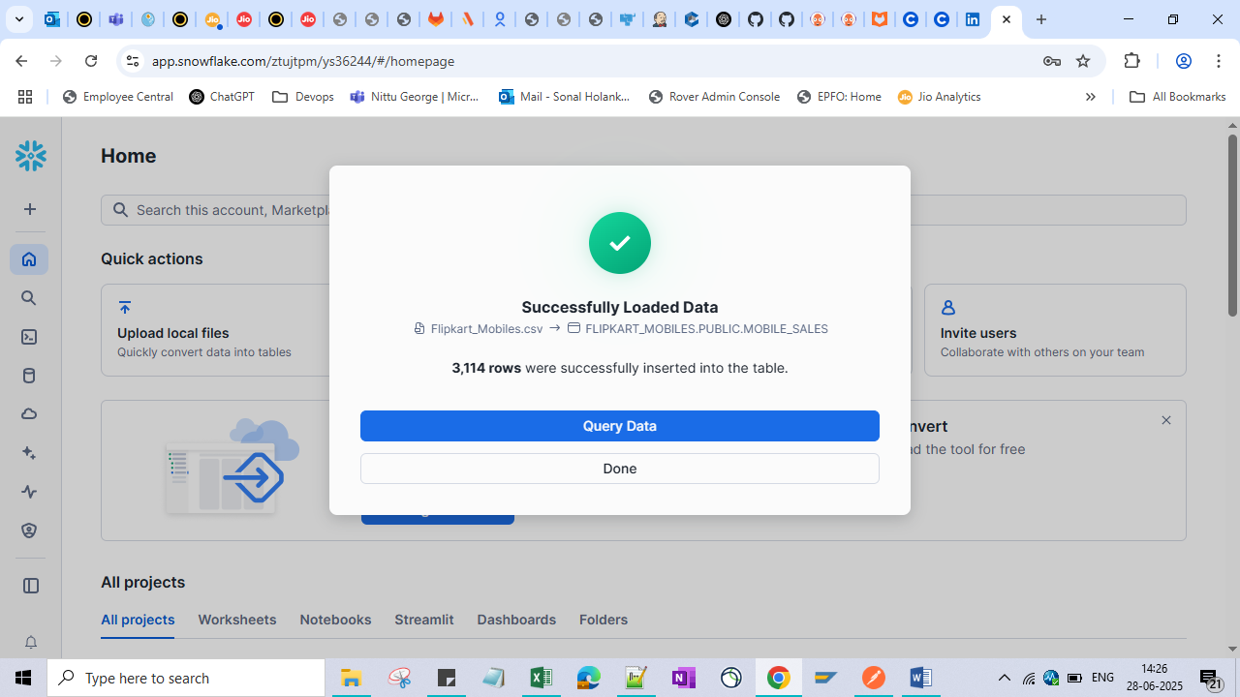

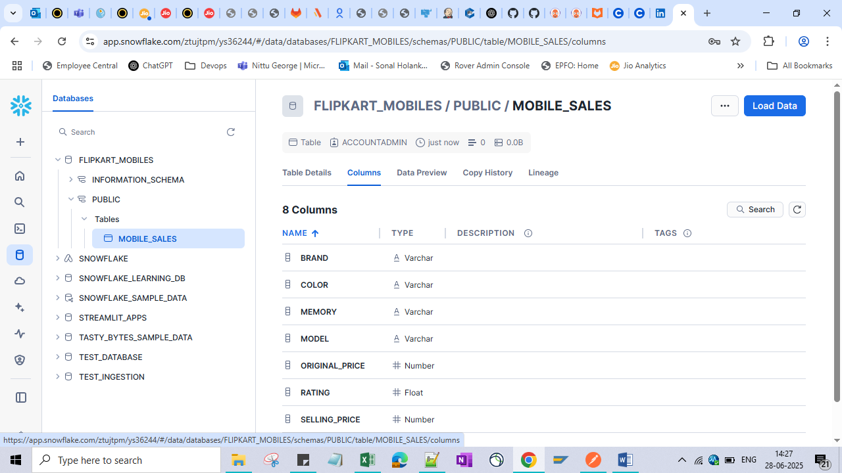

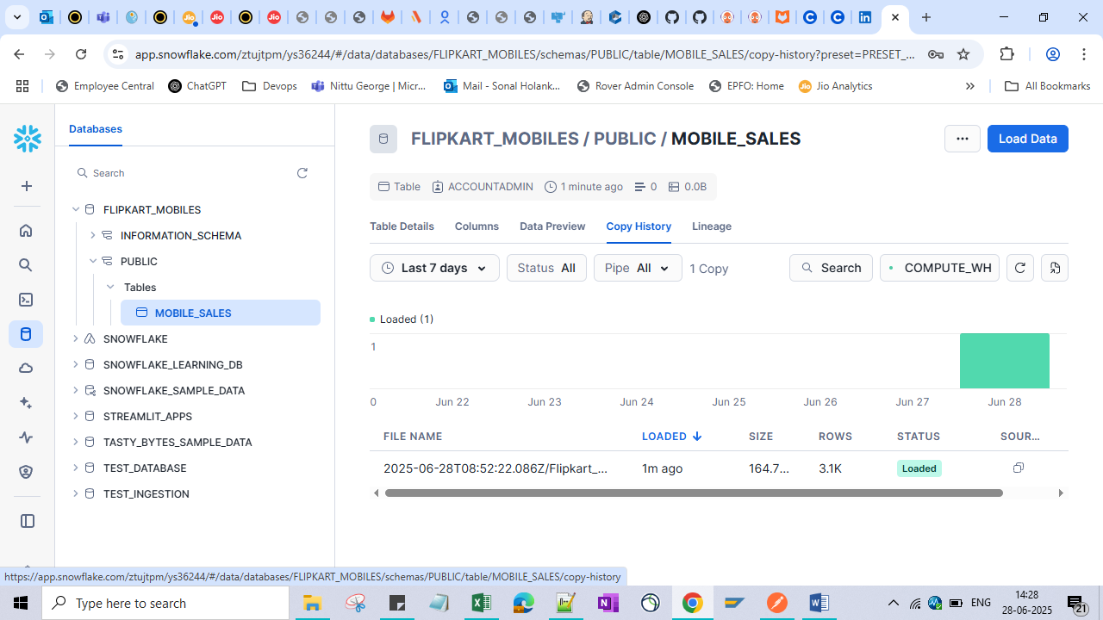

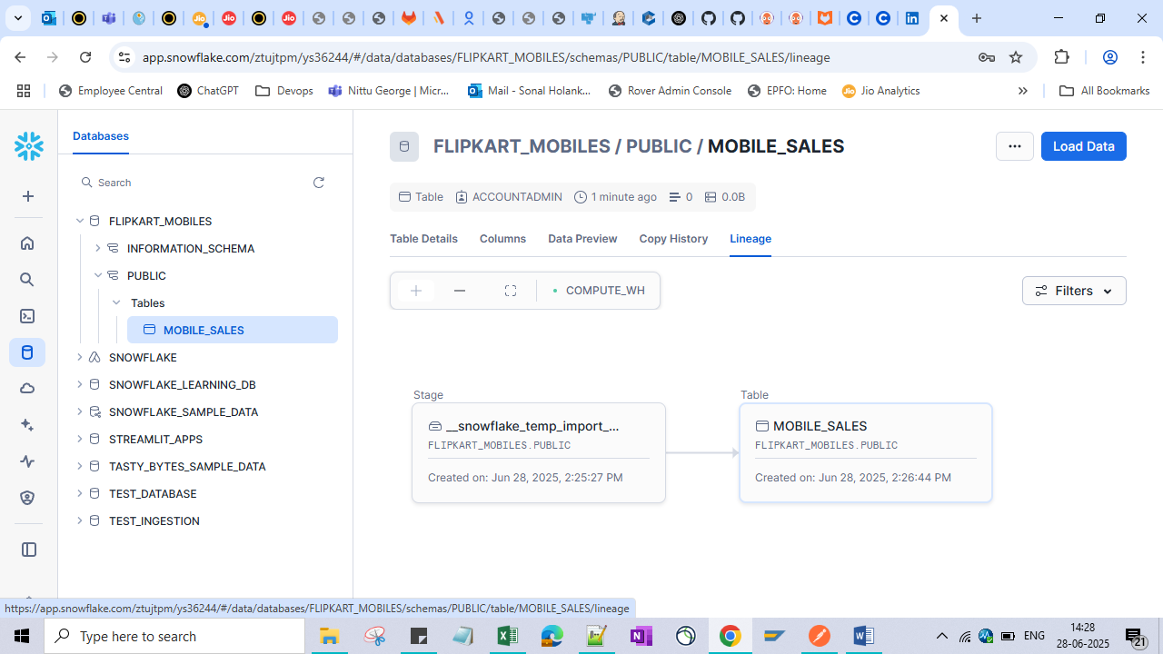

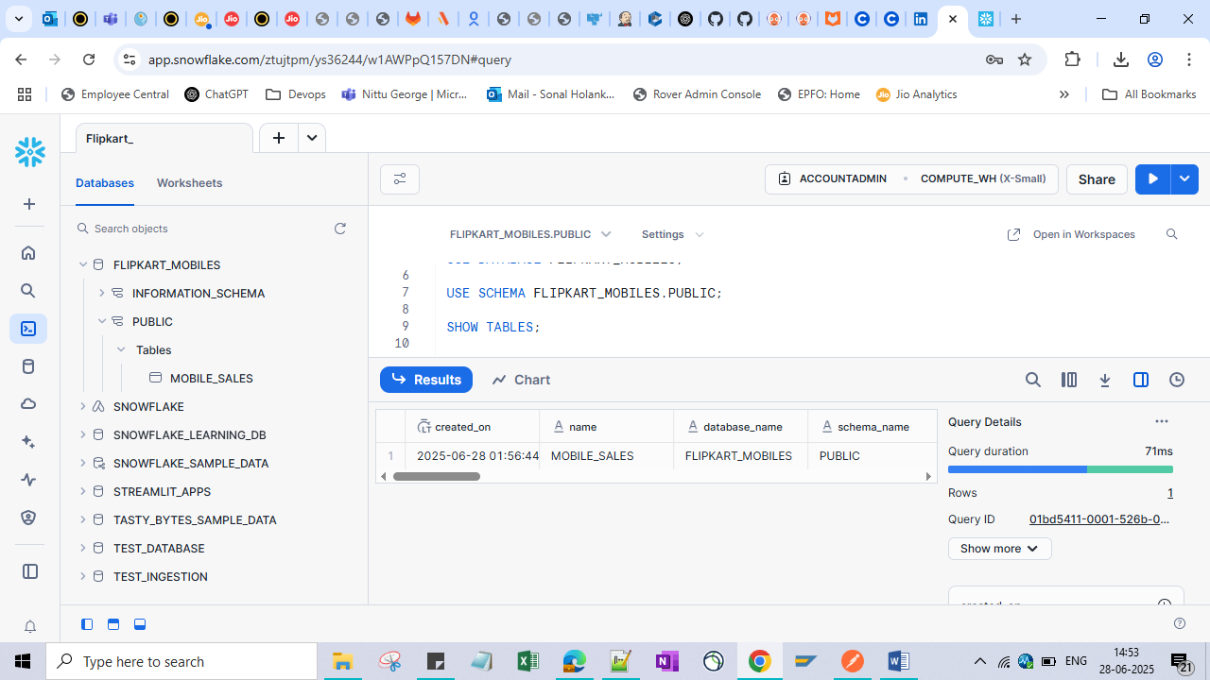

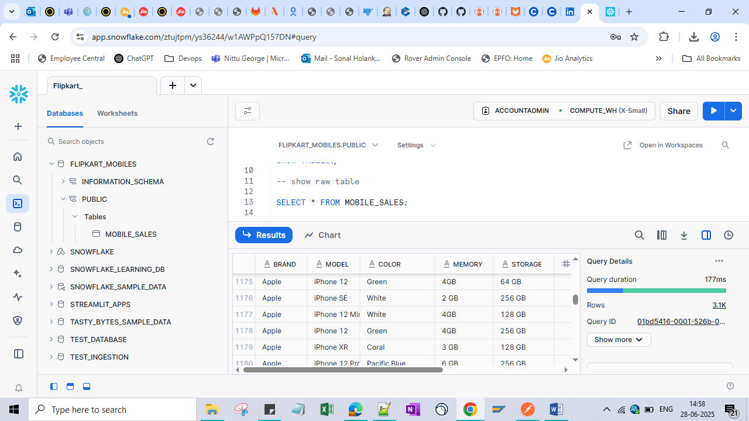

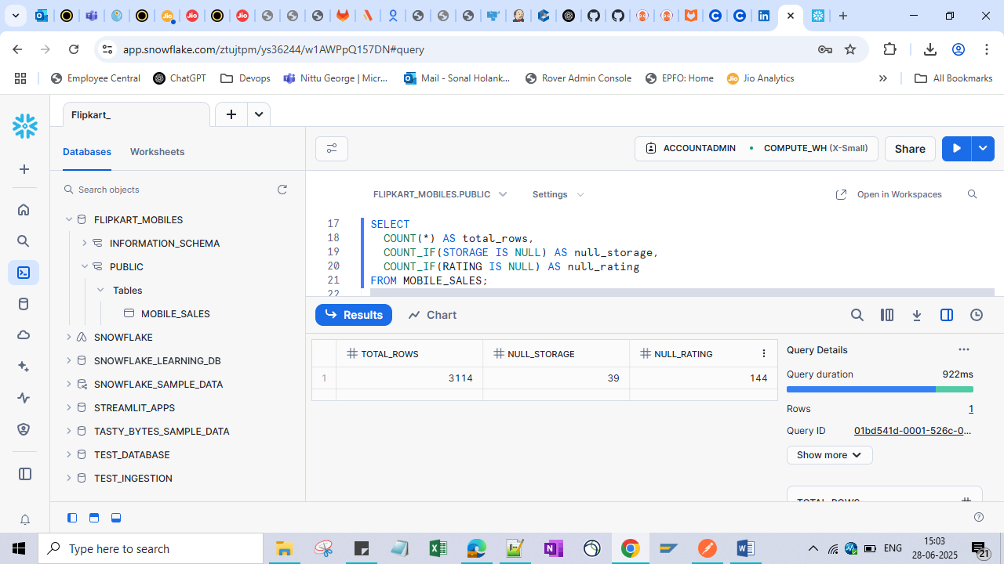

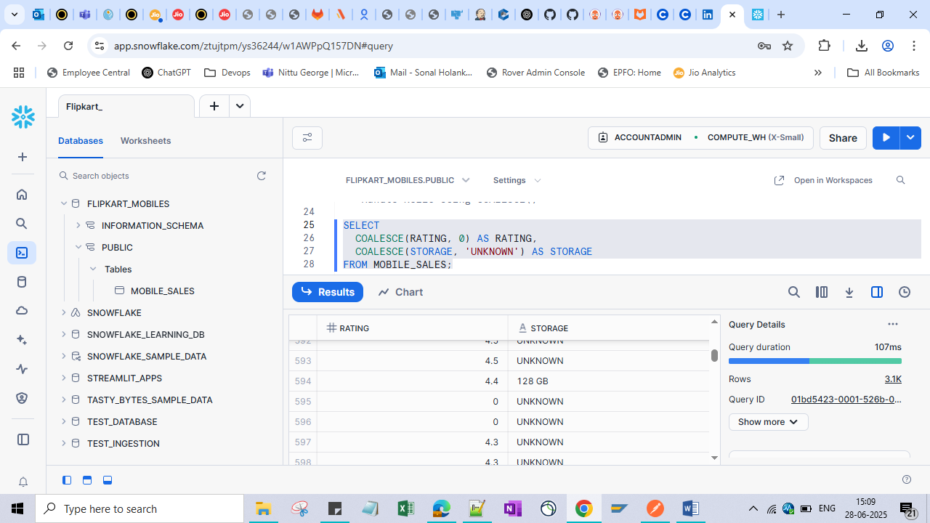

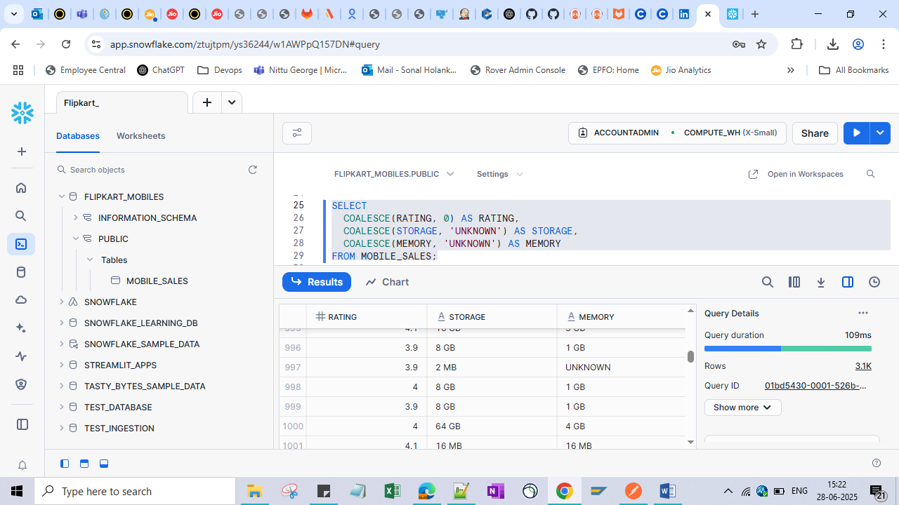

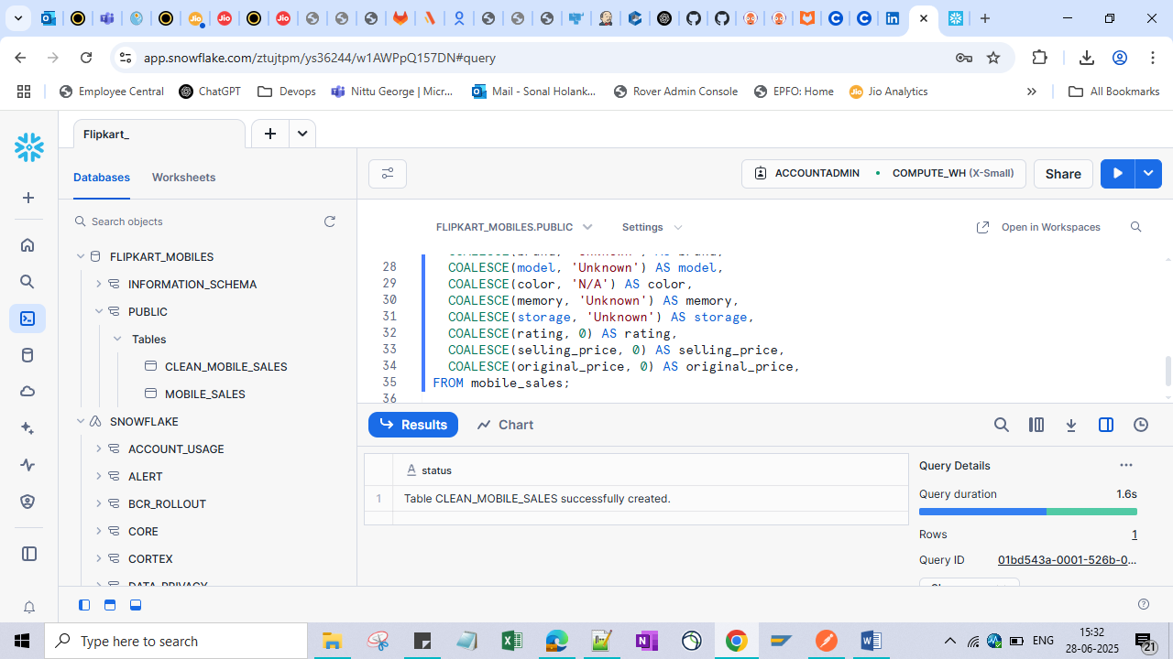

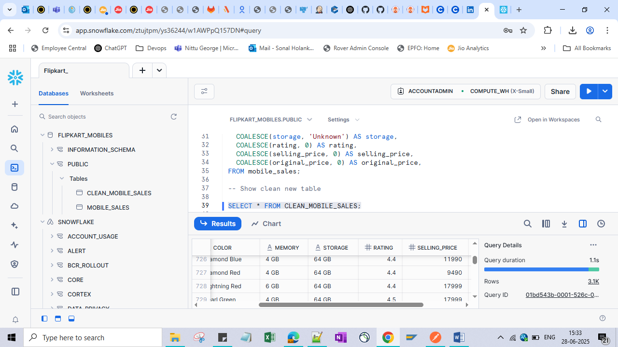

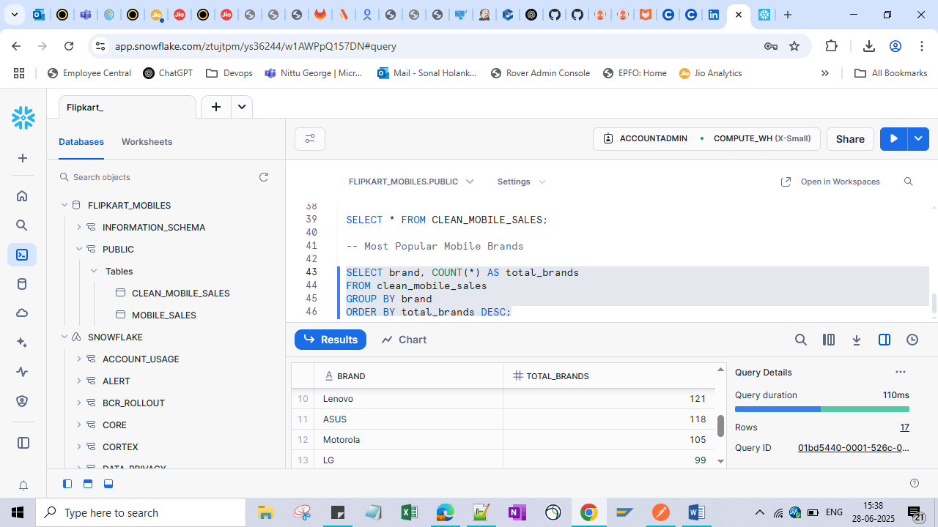

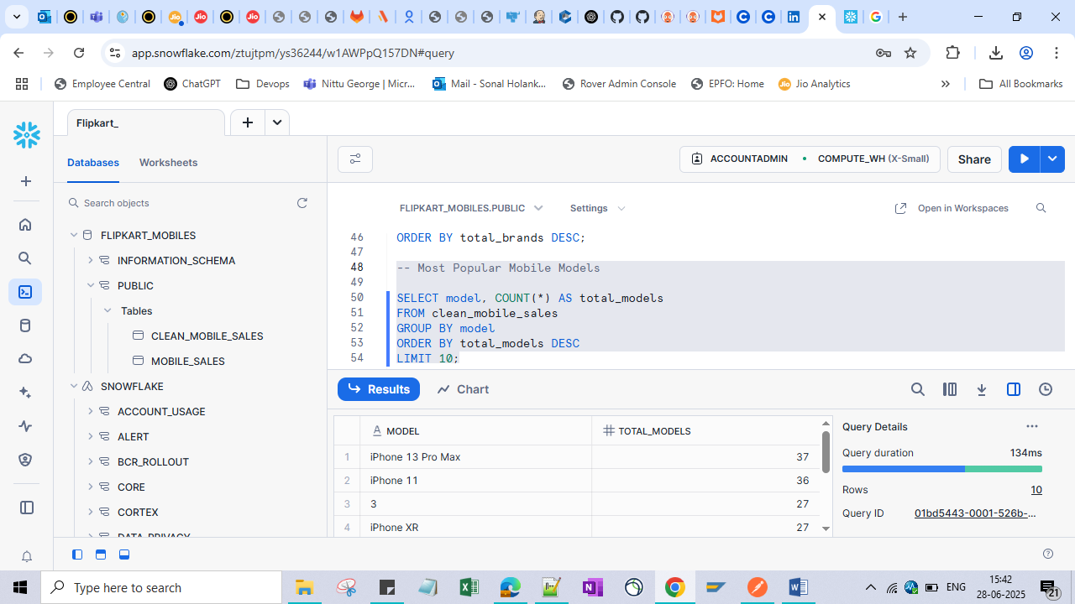

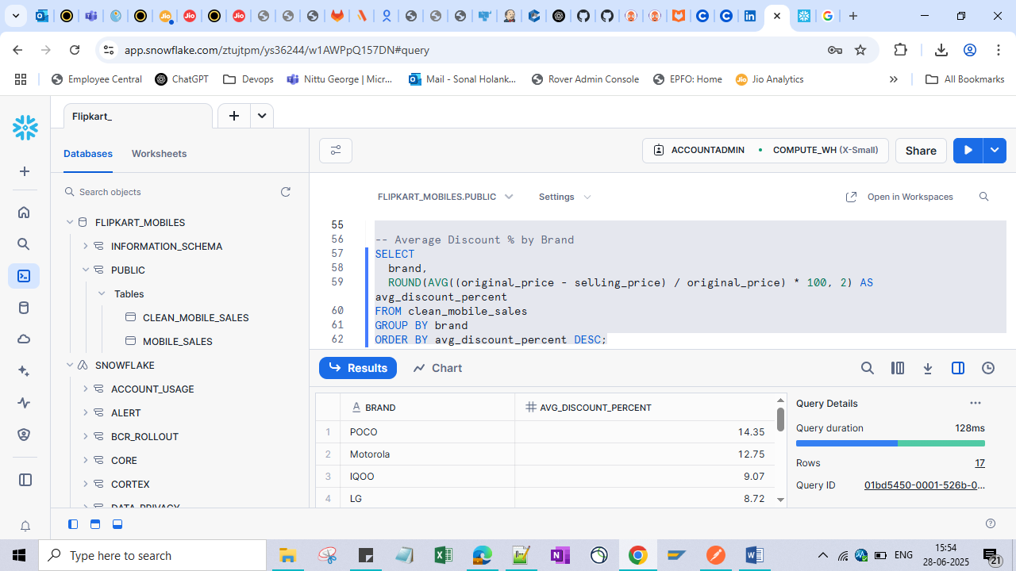

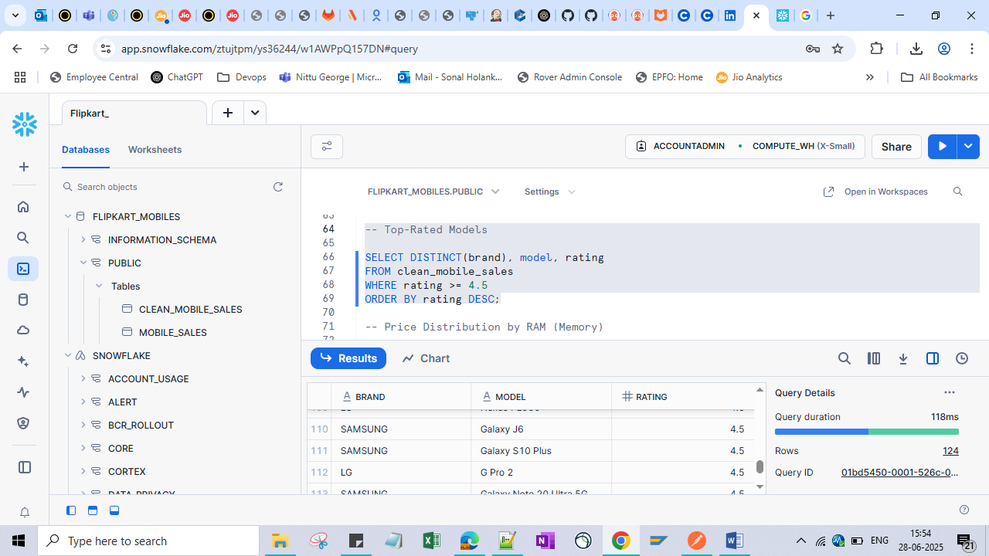

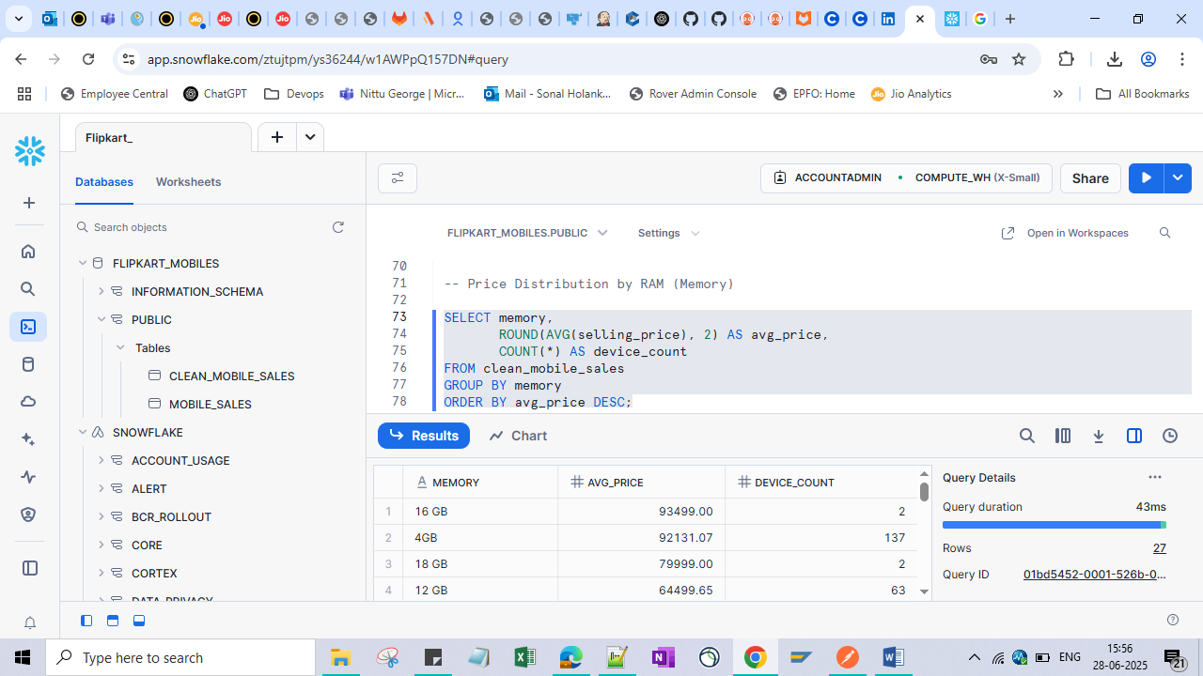

**Flipkart Mobile Sales Dashboard Using Streamlit App**

